Test chatbot creation using own custom data (PDFs)
Steps in summary:
- Create resource group
- Create storage account > create Blob container > upload PDFs
- Create AI search > create indexer
- Create openai resource > create deployment model
- Enable relevant RBAC roles as per screenshot in second last page
- Link data source (blob container) to chatbot

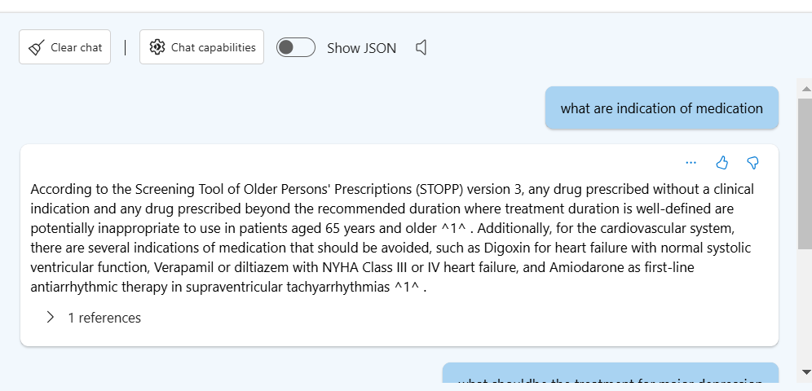
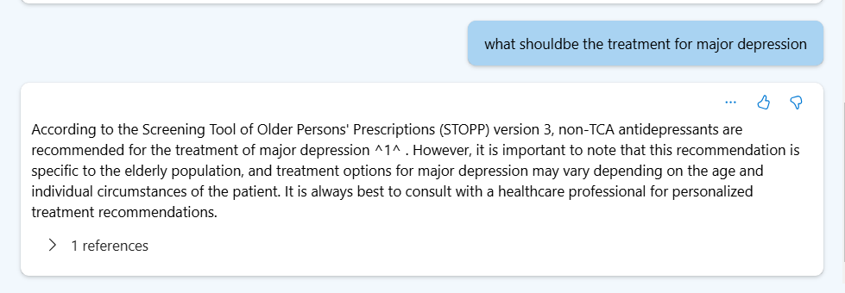
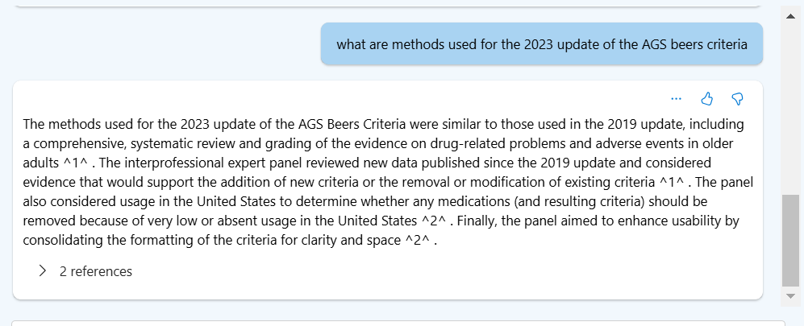

Not all pdf able to have data ingested due to using standard SKU for AI search service
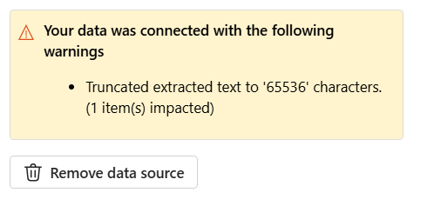

Setup:
Create storage account and container inside with blob data (PDF)
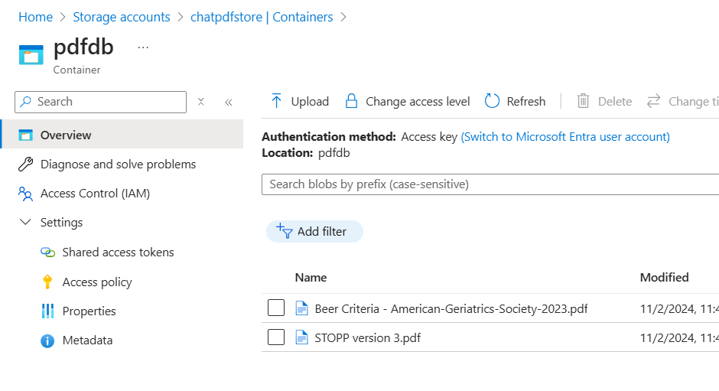
Create AI search resource:
- Point data source to container with your PDFs
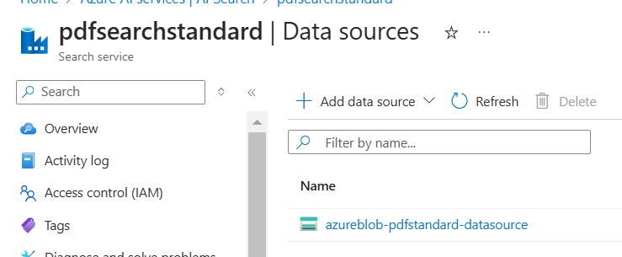
- Add indexer
- 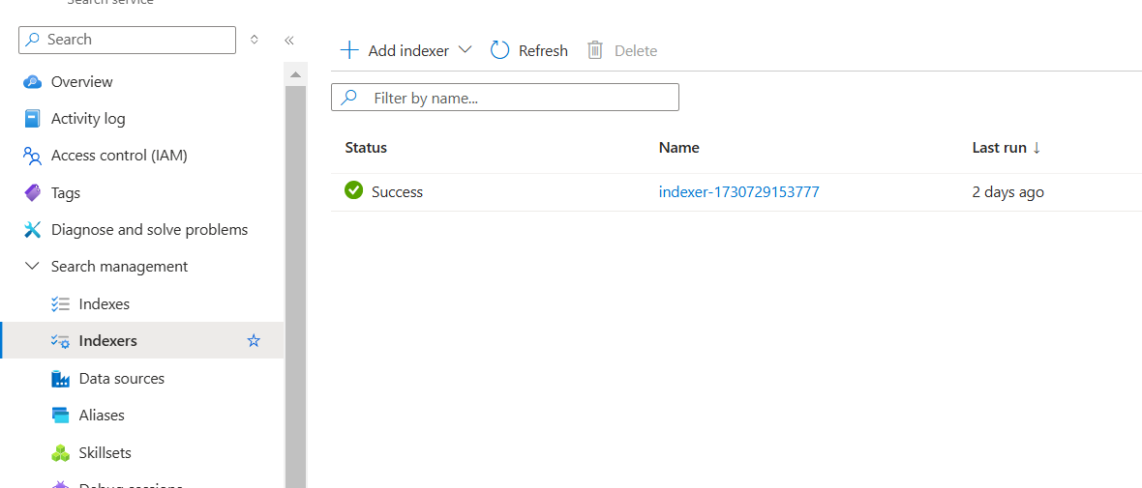

Create OpenAI resource
- Add deployment model (GPT3.5)
-Data source: Azure blob storage
- Storage resource choose your storage account
- Storage container choose your created blob container
- Azure AI search resource choose your AI search resource
- Indexer scheduler choose “once” if you don’t plan to do frequent updates to your container data

To note:
for Cognitive Services user role add in for AI search resource
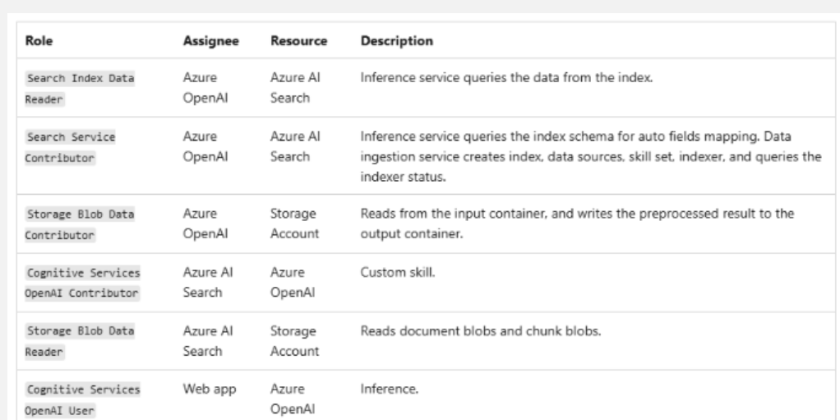

For AI search resource enable API access control for both RBAC ad API key
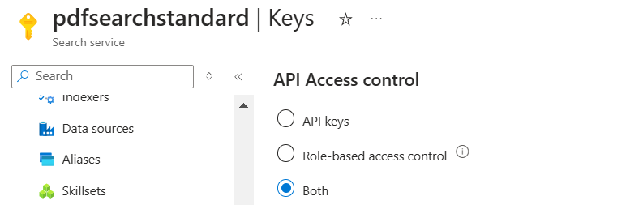
For AI search resource under identity > system assigned toggle to on. Same for other resources which you need to add roles to.
